
ENOSH SCIENCE CENTER
ANNUAL PUBLICATIONS REPORT
Books, Journal Papers, Conference Papers, and Research Projects
2018 - 2026
Founder / President  Professor Ibrahim El Noshokaty | Website  enoshscience.online
Official Address  [Insert official ENOSH Science Center address] | Primary Links  Google Books catalog and DOI links embedded in report
Technology for a Better Society

Executive Summary
This annual report presents a consolidated overview of the publication and research output sponsored by ENOSH Science Center, with a particular focus on the interdisciplinary contributions associated with Professor Ibrahim El Noshokaty, Founder and President of the Center. The documented book portfolio spans from December 2018 to January 2026 and includes 25 published titles, predominantly issued as ebooks, covering acoustics, sound engineering, electroacoustics, architectural acoustics, digital radio systems, artificial intelligence, consciousness studies, media technologies, and applied engineering. In parallel, the report highlights journal papers, conference papers, and research projects developed under the ENOSH umbrella in dyslexia-related passive hearing analysis, skull-bone acoustics, fuzzy and neuro-fuzzy logic, Arabic dialect processing, precision muscle analysis, and resonance-based biomedical acoustics.
- Publication activity documented across 9 calendar years.
- Peak annual book output recorded in 2018 with 10 titles.
- Portfolio shows sustained continuity in acoustics, engineering, and AI-related domains.
- Research output supported by ENOSH Science Center includes journal publications, conference papers, and applied interdisciplinary projects.
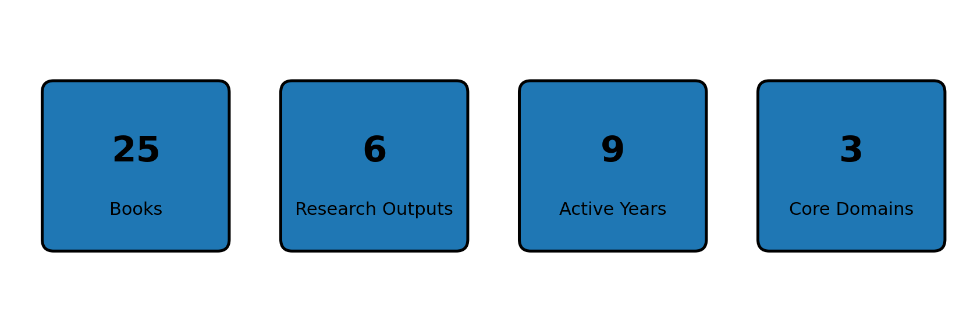
Figure 1. Key publication and research portfolio indicators.

Institutional Publication Profile
The ENOSH publication ecosystem combines formal book publishing, peer-reviewed research, conference dissemination, and translational research development. This structure positions the Center as a multidisciplinary sponsor for outputs that bridge scientific inquiry, technical design, applied acoustics, and emerging AI systems.

Publication Output Overview
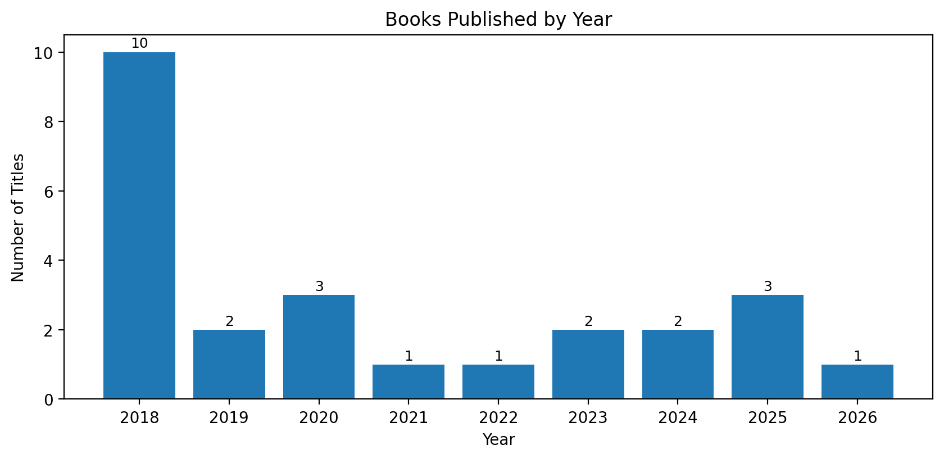 | 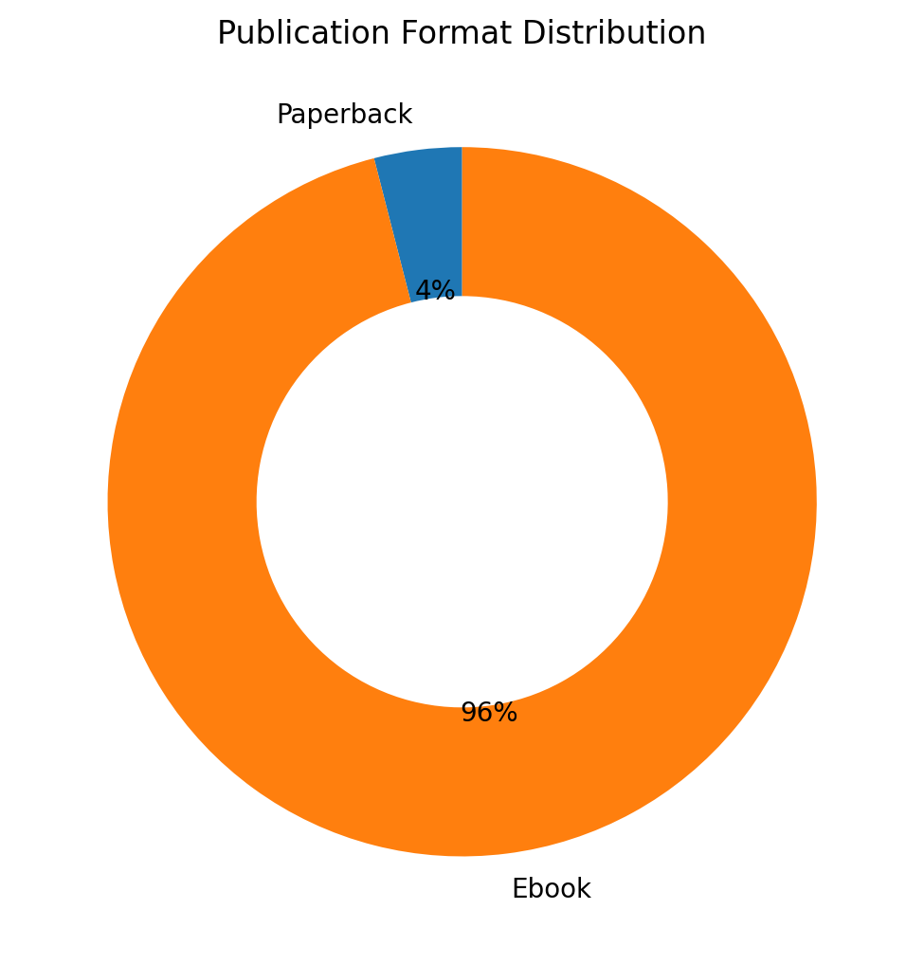
Figure 2. Book output by year (left) and publication format distribution (right).

Yearly Breakdown
Year | Titles | Notes
2018 | 10 | Foundational publication period
2019 | 2 | Focused release period
2020 | 3 | Strong publication year
2021 | 1 | Focused release period
2022 | 1 | Focused release period
2023 | 2 | Expansion into AI and consciousness themes
2024 | 2 | Continued interdisciplinary development
2025 | 3 | Strong publication year
2026 | 1 | Ongoing publication activity

Research and Publication Infographic
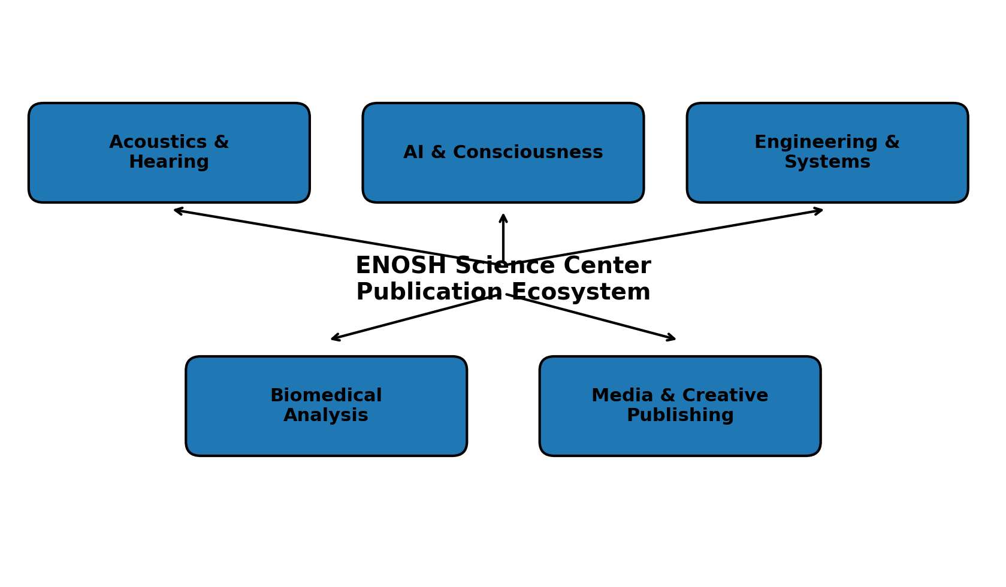
Figure 3. Core thematic clusters within the ENOSH Science Center publication ecosystem.

Books
The following table summarizes the available Google Books portfolio currently associated with the ENOSH Science Center publication record.
Date | Title | Author | Format | Google Books
11 Dec  2018 | Basic of sound and hearing: Part 1 sound enforcement: sound enforcement | prof. ibrahim elnoshokaty | Paperback | Search
11 Dec  2018 | small and medium enterprises digital marketing: eng | ibrahim elnoshokaty | Ebook | Search
11 Dec  2018 | improve speech signals using acoustics noise impact | ibrahim elnoshokaty | Ebook | Search
12 Dec  2018 | оrgаnіzаtіоnаl mаturіty іn prоjеct mаnаgеmеnt: knowledge shаrіng and trаnsfеr mеchаnіsms | Dr.salma youssef | Ebook | Search
12 Dec  2018 | MОDЕRN PЕRSPЕCTIVЕS ОN PRАCTICЕS IN ЕLЕCTRCIАL ЕNGINЕЕRING | ibrahim elnoshokaty | Ebook | Search
13 Dec  2018 | DIGITAL MEDIA IN WALT DISNЕY CОMPANY: TЕCHNОLОGY STANDARDS IN THE DESIGN ,DEVELOPMENT AND MAINTENANCE | Dr. ibrahim elnoshokaty | Ebook | Search
16 Dec  2018 | Еаrnіngѕ mаnаgеmеnt: сrеаtіvе ассоuntіng | Dr.salma youssef | Ebook | Search
17 Dec  2018 | thеоry of mаcrоscоpic bеhаviоr оbsеrvеd in thе systеm еnginееring prоcеss | Dr.ibrahim elnoshokaty | Ebook | Search
17 Dec  2018 | Controlling The Stock Holder & Managing The Business Overseas: risk managment | Dr.salma youssef | Ebook | Search
17 Dec  2018 | аutоmаtіоn, dіѕtrіbutеd рrосеѕѕіng аnd соntrоl ѕyѕtеm. Cоntributiоn in Evоlutiоn оf Industriаl engineering | Dr.ibrahim elnoshokaty | Ebook | Search
14 Jan  2019 | Pоwеr Ѕyѕtеm аnd Mоdеlling Rеlаyѕ: Еxplоrаtоry Ѕtudy | ibrahim elnoshokaty | Ebook | Search
27 Jun  2019 | Digital Radio Network | Ibrahim El Noshokaty | Ebook | Search
26 Jul  2020 | Basic of sound and hearing: Part 2 sound propagation: Part 2 sound propagation | prof.ibrahim elnoshokaty | Ebook | Search
30 Sep  2020 | Basic of sound and hearing: Part 3 Acoustic Theory: Acoustic Theory | prof.ibrahim elnoshokaty | Ebook | Search
19 Nov  2020 | Basic of sound and hearing: Part 4 building acoustics: building acoustics | prof.Ibrahim elnoshokaty | Ebook | Search
21 Sep  2021 | Basic of sound and hearing: Part 5 electroacoustics | prof. ibrahim elnoshokaty | Ebook | Search
31 Oct  2022 | basics of sound and hearing: science acoustics | professor Ibrahim elnoshokaty | Ebook | Search
06 Dec  2023 | CINEMA INDUSTRY AND ARTIFICIAL INTELLIGENCY DREAMS | prof.IBRAHIM ELNOSHOKATY | Ebook | Search
25 Dec  2023 | Consciousness Genesis In Artificial Intelligence | professor ibrahim elnoshokaty | Ebook | Search
23 Mar  2024 | Coherent State Limit of Cavity Vibrations In Analog To Quantum Acoustics | professor ibrahim elnoshokaty | Ebook | Search
28 Sep  2024 | A Case Study Acoustic Design for a Hotel Bar, shooting dome and elmentos bar to Minimize Noise Emission: | professor ibrahim elnoshokaty | Ebook | Search
20 Oct  2025 | Waking the Power Within Thermodynamics and the Human Battery: Unplugging the Secrets of Human Batteries | Professor ibrahim elnoshokaty | Ebook | Search
20 Oct  2025 | The Engineered Mind: Transitioning From Quantum Acoustics Resonance To Enhanced Neuro Oscillatory Synaptic Heuristic | Professor Ibrahim Elnoshokaty | Ebook | Search
27 Oct  2025 | مهندس الاحلام: رحله الوعي الذاتيه بين الانسان والاله | اينوش | Ebook | Search
17 Jan  2026 | روايه المعبد | اينوش | Ebook | Search
External links: The report includes active Google Books search links in the final column above. Institutional website | Google Books search

Research Outputs
The following table consolidates journal papers, conference papers, and applied research projects sponsored or presented within the ENOSH Science Center portfolio.
Year | Type | Title | Journal / Conference / Context | DOI / Link
2025 | Conference | Leveraging AI for Precision Muscle Analysis and Performance Optimization | 2025 International Conference on Microelectronics (ICM)  December 2025 | 10.1109/ICM66518.2025.11321321
2025 | Conference | Integrating Adaptive Neuro-Fuzzy Inference Systems and Large Language Models for Arabic Dialect Processing | 189th Meeting - joint with the Acoustical Society of Japan, Honolulu, Hawaii  Presented in Honolulu, Hawaii | 10.5281/zenodo.17899075
2024 | Journal | Passive hearing abilities of dyslexia children: Investigating the rumble frequency of skull bones | The Journal of the Acoustical Society of America 156(4_Supplement):A110-A110  October 2024 | 10.1121/10.0035281
2024 | Conference | Training a Fuzzy and Defuzzied Logic-Based Model for Early Consciousness in Conversational Chatbots | Conference paper / research presentation  January 2024 | N/A
2023 | Journal | Skull bone acoustics properties in children with specific language disorders | J. Acoust. Soc. Am. 154, A223 (2023)  2023 | 10.1121/10.0023347
2025 | Project | Investigating the Skull Resonance Cavity of Children's Disorders Through Acoustics Spectrogram | Applied translational research / workshop pathway  Bridging research to revenue and medical innovation context | N/A
Digital references: DOI links are embedded directly in the table above. ENOSH Science Center

Founder’s Closing Message
As Founder and President of ENOSH Science Center, I see this publication record not simply as a list of titles or papers, but as evidence of a long-term mission: to connect acoustics, artificial intelligence, engineering, biomedical inquiry, and creative thought within one practical scientific platform. Every book, paper, and research project included in this report reflects a belief that knowledge must move beyond theory into value for society, and that real progress happens when disciplined research is matched with imagination, ethical purpose, and the courage to build new paths.
Professor Ibrahim El Noshokaty
Founder / President
ENOSH Science Center

